ANSIBLE[Task-2]

# 1) Watch ansible-02 video and write down notes.

# 2) Install httpd using ansible playbook, use

# handlers,notifiers.

Steps:

Creating a directory[mkdir playbooks]

Cd playbooks

Vi apache.yml



1)Installing apache on servers using playbooks

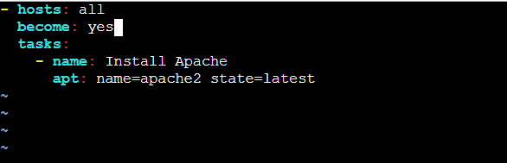

Executing the playbook

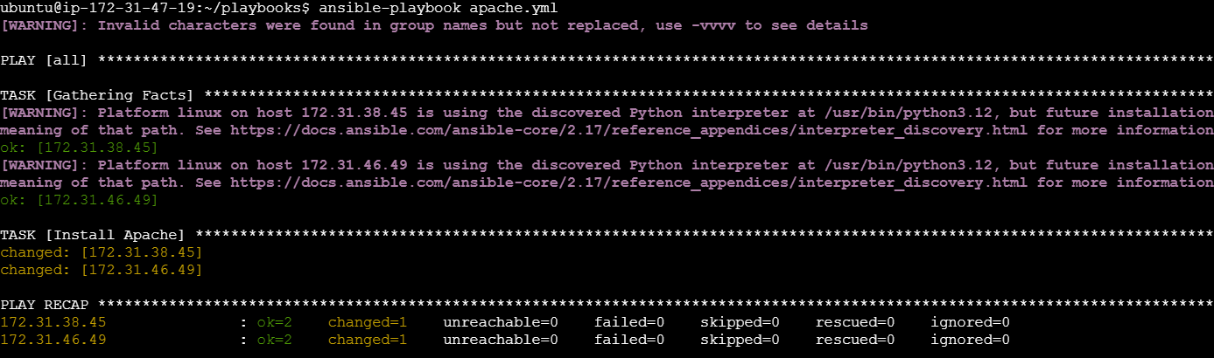

3)Deploy one index.html

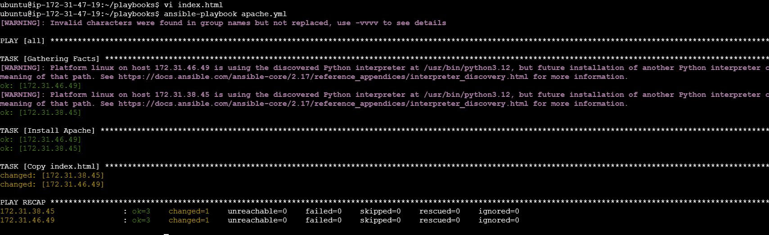

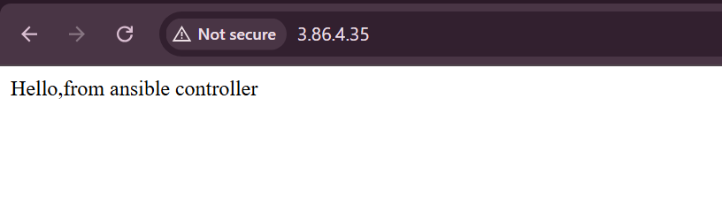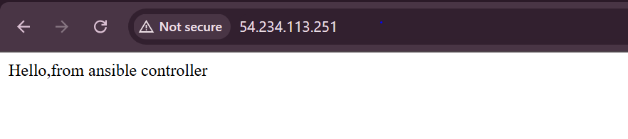

3)Restart my apache2 server

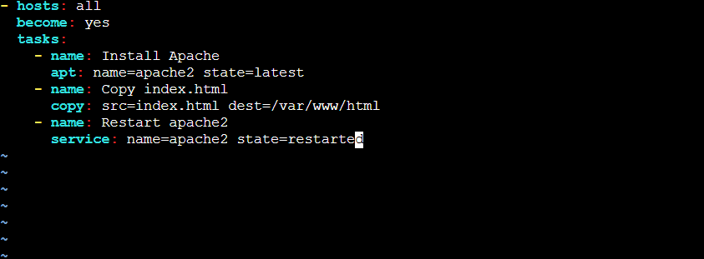

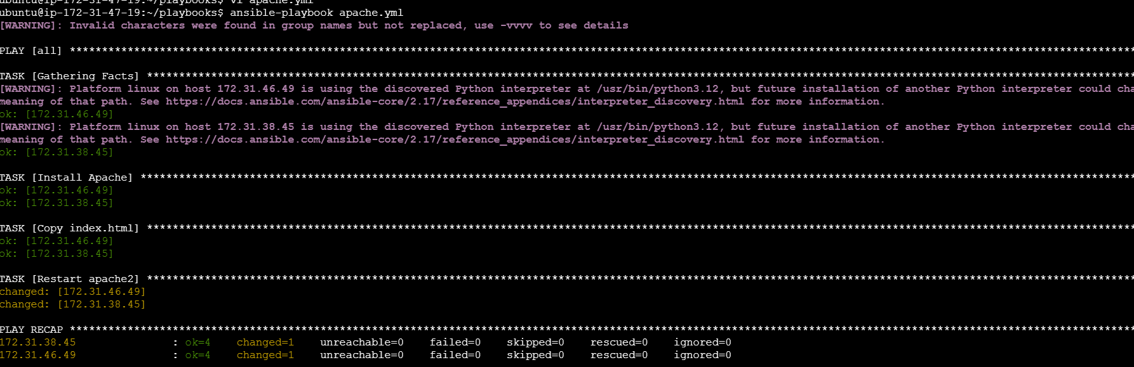

We can check the process id[two ids generated]

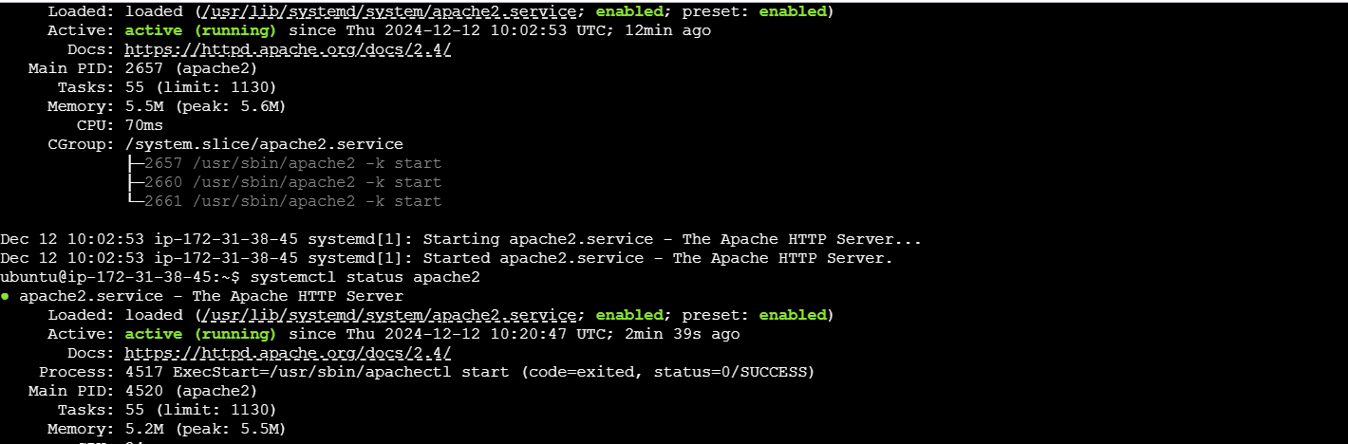

4)Notify/handlers

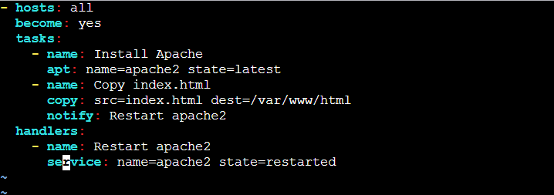

Edited the index.html file,so that handlers will trigger

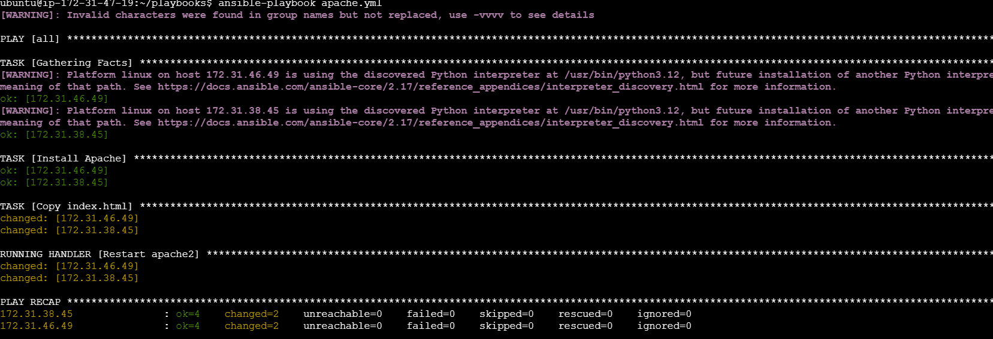

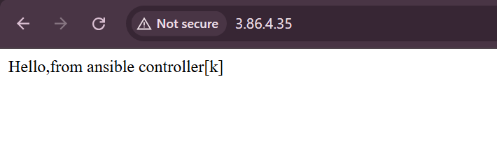

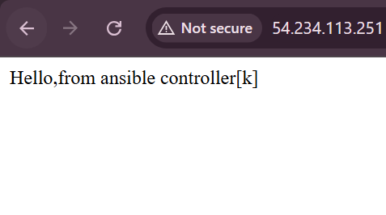

# 3) Write a ansible playbook to install apache tomcat.

Creating a playbook tomcat.yml

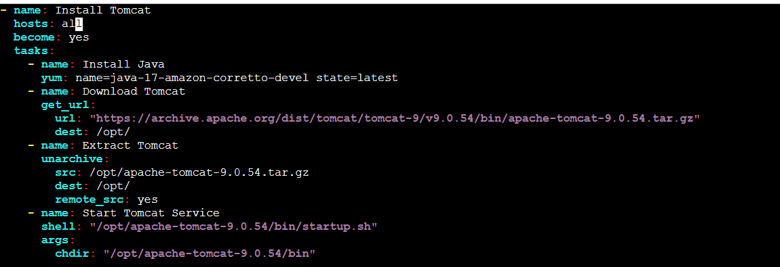

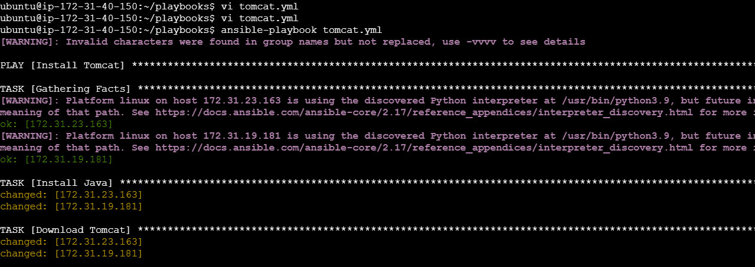

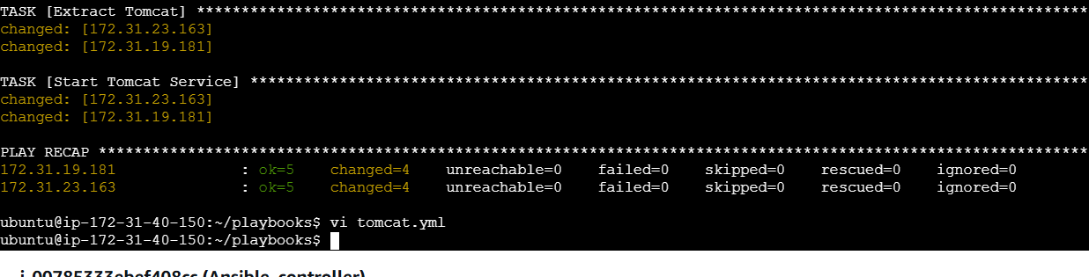

We can also check with the ips of workers machine

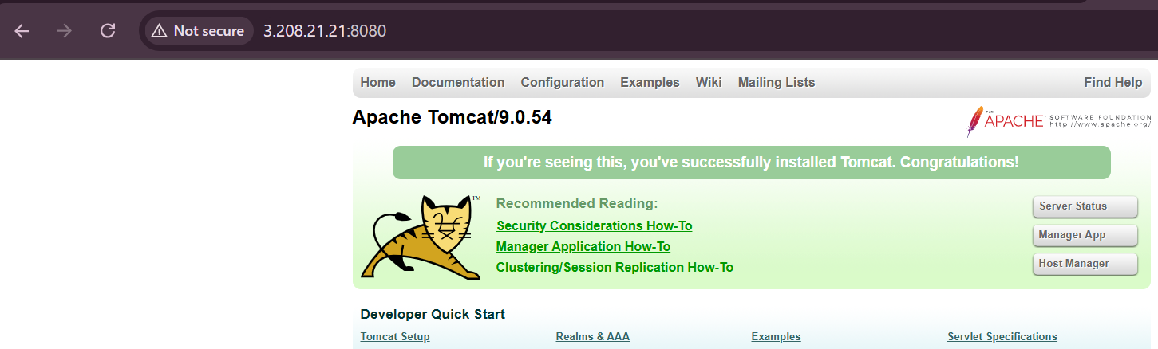

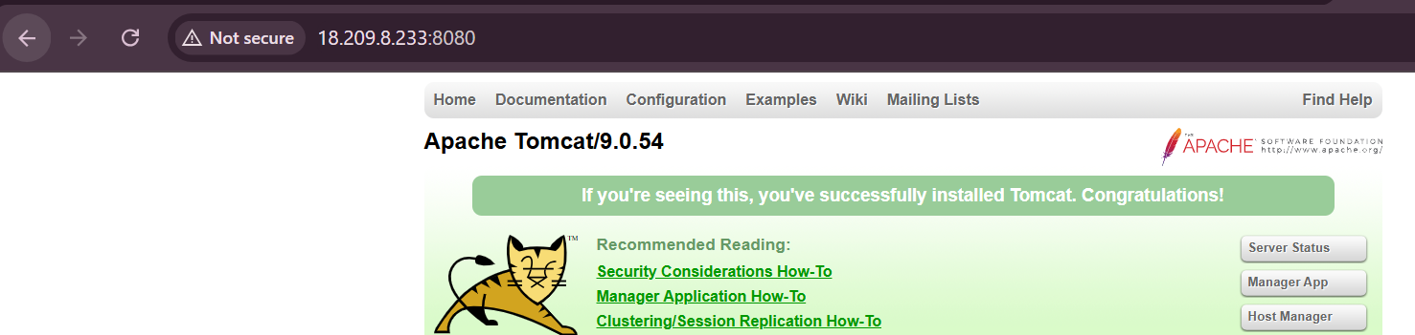

# 4) Write a ansible playbook to provision one ec2 on aws.

Passing Environment Variables in the playbook directory



Created a playbook 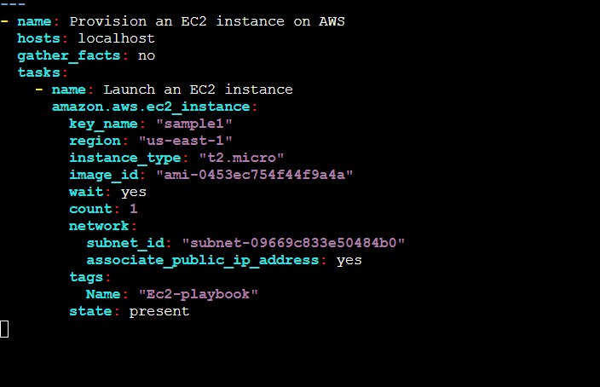

Execution:

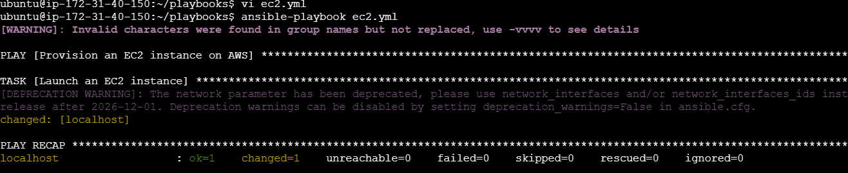

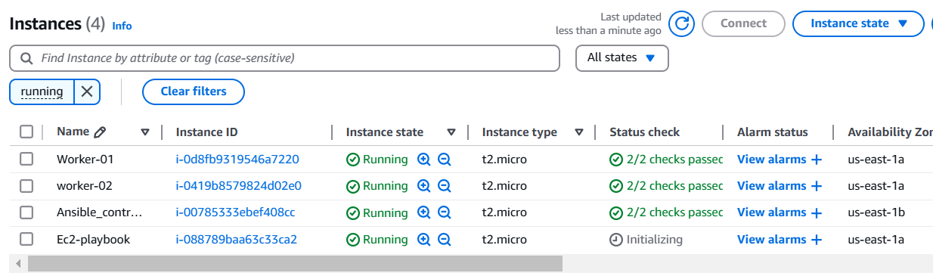

# 5) Write a ansible playbook to copy one file from node-1 to node-2.

Created a playbook with the name copy.yml

Added the script

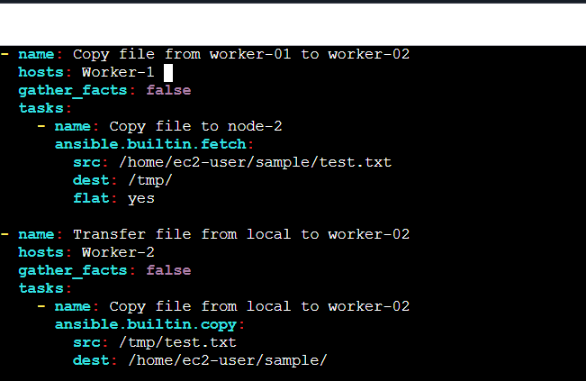

Executing the copy.yml file with the command

*ansible-playbook -i /etc/ansible/hosts copy.yml*

EXECUTION

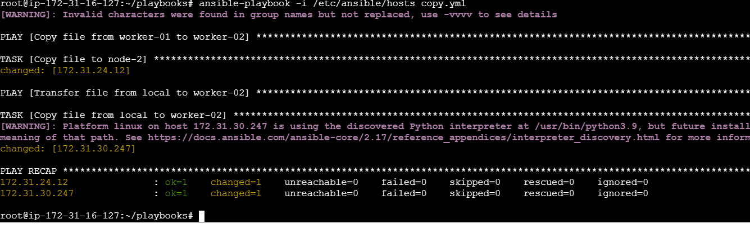

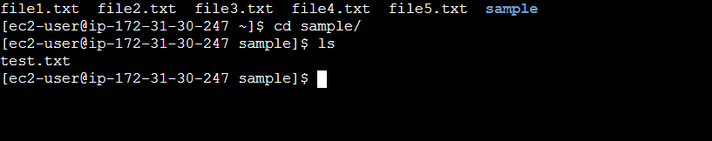

# 6) Write a ansible playbook to create different files with different names using single playbook.

